


WORK EXPERIENCE
INFORMATION PACK

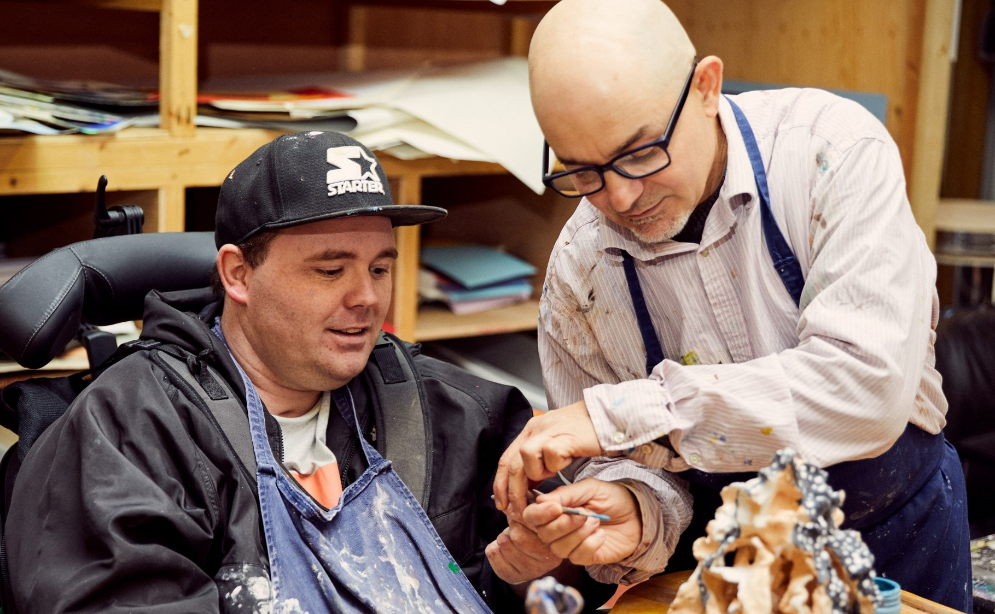
Role Details
Registered Charity No: 1083910.
Role: Work Experience Volunteer
Based at: Headway London, Bradbury House, Timber Wharf Block B, 238-240 Kingsland Road E2 8AX
Days/Times: Two weeks, Monday-Friday, 10am-3pm
Responsible to: Volunteer Coordinator
Main Purpose: Supporting our services and projects for brain injury survivors, working in direct contact with our service users (members)

About Us
Headway London (https://www.headwaylondon.org) is a charity supporting people affected by brain injury.
Working across 13 London boroughs we offer specialist support and services for survivors and their families. We offer therapies, advocacy, family support and community support work alongside our day service: a community venue where people can make the most of their abilities and interests. We also promote awareness and understanding of brain injury by providing information to
the public, and offering training to university students, professionals and businesses.
Our vision is to build a community where people with brain injury are valued, respected and able to fulfil their potential.

Who are we looking for?
Headway London is currently looking for Work Experience Volunteers.
We are offering Work Experience opportunities to students 16 years old and over.
You will be based at our main centre in Haggerston where we offer a range of services and activities for brain injury survivors. You will get the opportunity to join our projects, support our members, join our lively community of volunteers and learn about brain injury.

Main Duties
- To assist members with specific activities that prove challenging for them i.e. using computers, cooking, engaging in art activities.
- To initiate discussion, games or activities and encourage members to take part.
- To help floor staff around lunchtime (food preps. setting up tables, dishing out and serving food).
- To assist with keeping the Headway house safe, clean and tidy at all times by taking on tasks such as collecting and washing cups, tidying up resources shelves, wiping tables before lunch etc.
- To inform floor staff about activities undertaken with members and any significant changes in mood or behaviour.
- To undergo training as required and attend volunteer debriefs and supervision.
- To undertake any other duties that may reasonably be required.

Person Specification
- Clear and sensitive communication.
- Ability to relate well to people on a one-to-one basis and be sympathetic to others’ situations.
- Patience and sense of humour.
- Common sense, flexibility and initiative.
- Committed, reliable and enthusiastic.
- Willing to participate in a variety of activities appropriate to the client group.
- Good interpersonal skills.
- Committed to equal opportunity issues and respectful of confidential information.

Commitment
Monday to Friday 10am-3pm for two weeks. We are happy to accommodate school work experiences, please forward the relevant paperwork recruitment@headwaylondon.org.

Selection
The selection process is as follows:
- Fill out a short application form (available on our website) and provide two referees. One of these can be your parent or carer. Send it to recruitment@headwaylondon.org.
- On receipt of satisfactory references the applicant will be contacted by the Volunteer Coordinator.
- A start date will be agreed.
- You will receive a Work Experience Handbook to read through and will have a catch up with the Volunteer Coordinator on your first day.
- You will be asked to sign a Volunteer Agreement, Confidentiality, and Consent form.

A visit to the centre from 10am-12pm can be arranged before filling out the application form. After this a date and time for a catch up with the Volunteer coordinator will be arranged before starting the experience.

Registered Charity No: 1083910.


Registered Charity No: 1083910.

Benefits of volunteering with us
At Headway we value our volunteers and their contributions to the organisation. We provide references and in addition to this some of the additional benefits are:

Training/Support
Each volunteer is given a basic induction which includes information on health & safety, fire precautions, confidentiality, equal opportunities, and a brief outline of the long-term effects of head injury.
There will be an opportunity to attend a volunteer meeting which will take place 10.00am -10.30am and meet other volunteers.
Travel expenses to and from Headway London are paid. (Car mileage or public transport costs within London only). Free lunch is also provided at the centre or alternatively we reimburse up to £3.50 for lunch expenses.
For any expenses claimed a receipt must be provided.

We have a vivacious team of volunteers some of which have been volunteering with us for over 20 years.
We celebrate our volunteers and are constantly working towards providing new opportunities. Volunteers are very much appreciated at Headway London and make an invaluable contribution to our work.

